Wooded Glen, Section I Homeowners' Association, Inc.
October 2017
http://woodedglenhoa.org/http://woodedglenhoa.org/
NEWSLETTER

ANNUAL HOA Meeting NOVEMBER 2017
The annual meeting of the Wooded Glen, Section I Homeowners’ Association Inc., has been scheduled for 6 November, 2017, at 7:30p.m. at the Pohick Regional Library. At least one homeowner from each home should attend to represent their home in the Association.

Elections will be held to fill three Board member positions for two-year terms (Nov 2017 – Nov 2019). Al Graziano, Mike McCrory, and I will be completing our terms on the Board. Al has been the HOA’s treasurer for many years, and he has provided outstanding services to the HOA in that capacity. We all should be grateful to him for the time and effort he has expended over his many years of service to ensure that the HOA’s finances are properly maintained.
Because of the looming board vacancies, the current board is nearing agreement with a management company to ensure (i) that the HOA is compliant with all state laws, and (ii) that our homeowners are compliant with our by-laws and covenants. If the agreement is finalized, we will have to decide how to pay for the management company’s services. We anticipate that the additional cost to each homeowner will be about $156 per year.
We see four possible scenarios. First, if we have homeowners who will volunteer to fill the vacate board positions, there might not be a need to retain a management company, in which event the annual assessment could remain unchanged.
Second, if we have no volunteers to take on the duties the management company will perform, then, to cover the cost of the management company, we could increase the annual assessment from the present $450 to about $600. Under our by-laws, such a substantial increase can take effect only with a 2/3 vote at a meeting with a quorum of 60 percent of the homeowners (or, if a 60 percent quorum cannot be achieved, at an adjourned meeting with a quorum of 30 percent).
Third, if we do not have the votes to increase the annual assessment, then, in order to cover the cost of the management company, the board could no longer pay for trash collection on behalf of the homeowners. Under this scenario, all homeowners will be required to arrange for their own trash collection.
Fourth, we could hire a management company and operate the association with a deficit budget, with funding taken from the association’s reserves.

In short, at this year’s annual meeting topics will be discussed and decisions will be made that will affect all of our HOA’s members. I therefore encourage you all to attend the meeting. I also encourage anyone interested in our HOA, and our neighborhood, to volunteer for a seat on the Board of Directors. It takes only a couple of hours a month of your time.

NEIGHBORHOOD SAFETY
Ours is a very safe neighborhood. Although in the past we have had some minor acts of vandalism and petty larceny, things have been quiet this year. Nevertheless, it is always wise to take common-sense precautions. Autos parked on the street have been targets of petty criminals in the past. To deter those who might be tempted, all homeowners should lock their cars and secure valuables out of site. And keeping your exterior lighting well maintained will also serve as a deterrent.

We’re all neighbors and should look out for one another. If you see anything suspicious, please contact 911 or the Fairfax County Police Department Non-Emergency Line at 703-691-2131. The best deterrent is a vigilant neighborhood.

REPLACEMENT BULBS, GLOBES and LAMP POSTS
Homeowners, please take a look at your lamp post. Some are showing their wear. The Board requests that the bulbs be uniform. All bulbs on the entire street should have the same wattage and color rendition. If you need bulbs, please contact the Grounds Committee or any of the Board members for replacement. The Grounds Committee has been helping homeowners replace bulbs. The Committee has also assisted in replacing rusted steel screws with stainless steel screws. Feel free to contact any member of the Grounds Committee for assistance.

You can also contact any member of the Grounds Committee for assistance in replacing the 12-inch plastic globes for your lamppost fixture.

PLEASE PICK UP AFTER YOUR PETS
Fairfax County Code Title 41 requires pet owners to have their pet on a leash when left outside and to pick up their pet’s waste. From time to time homeowners in Wooded Glen have noticed unleashed pets running around at night and pet droppings on their lawns, in the common areas, and in the parkland near the townhomes. Our children play in these areas. Remember to bring a bag and flashlight at night. Darkness does not hide the waste. Please DO NOT dispose into the sewer drains.

Anyone seeing a homeowner not picking up waste after his or her pet should politely ask the pet owner to do so. If the polite reminder does not work, violators may be reported to the Fairfax County Animal Warden at (703) 691-2131. However, aggressive actions against pet walkers are not recommended.

HOW TO CHANGE THE EXTERIOR OF YOUR HOUSE
Does the color of your house need a change? Do you wish you had a back deck or fence around your yard or do you want to change the one you have? Do you have a tree that needs to be removed? If so, then you have to request approval for an exterior change of your house from the Architectural Control Committee (ACC). The Wooded Glen guidelines state: “Applications shall be submitted to the Committee in an original plus five copies.” You can also send your application electronically to acc@woodedglenhoa.org. or Walter.Zimmers@gmail.com. Applications shall contain detailed drawings of changes to be made. Such drawings shall clearly indicate the location of existing structures, and property boundary lines.”

The approval process is simple; use the form located on our website or write a letter explaining exactly what you want to do, add a drawing, and if painting is involved, submit a sample of the color(s). Sometimes the ACC receives requests when nothing is really required. Before filling out the ACC forms, feel free to contact Mr. Zimmers at 703-646-2087, or email him at Walter.Zimmes@gmail.com. He will be happy to assist you as to whether or not ACC approval is required. If you send a request in hardcopy, you can provide Mr. Zimmers one copy with sample. He will then scan and circulate your request to the other members of the ACC once it is reviewed for compliance. A complete application normally takes no more than two days to be approved. Written approval of changes, additions or improvements to your home is a requirement of our Homeowners’ Association. To review the requirements in detail, see the link to the Architectural Guidelines on our web site at http://woodedglenhoa.org/.

HOA PICNIC FUN!
This year’s annual picnic was held on Saturday, September 16 and it was another great success. A big thank you goes to the many neighbors who pitched in to help make the afternoon enjoyable. Thank you to Debbie Draxler, Malia McLeod, the Tortolero family, the Ro family, Linda Hamm. A special thanks to Sham and Susan Wadhwa for making the delicious samosas and to David Samec and Michael McCrory for taking care of the grilling. A very special thank you to our homeowner/photographer, Victor Lloren for all the great photos that he captured. This was another great event organized by Debbie McCrory. The Board extends a huge thank you to Debbie for pulling it all together, again.

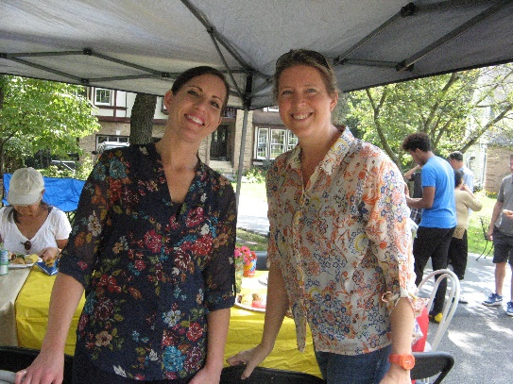
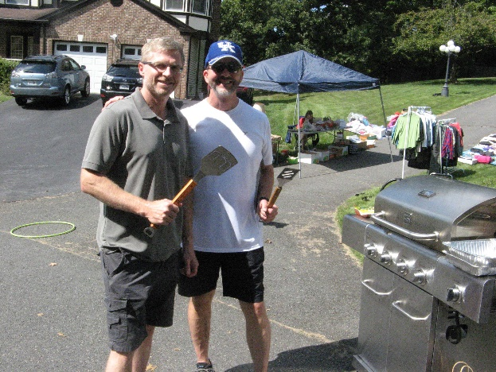

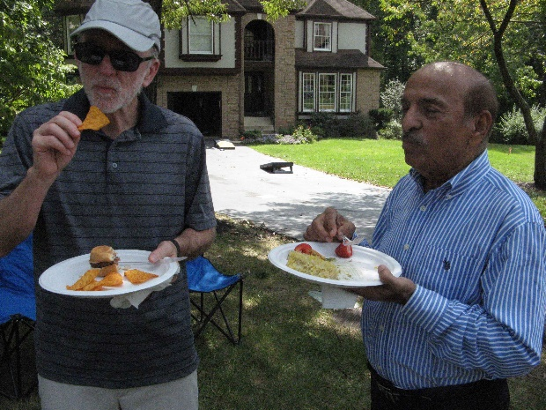
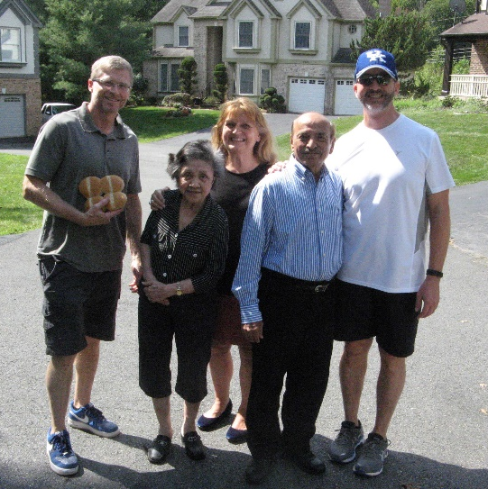
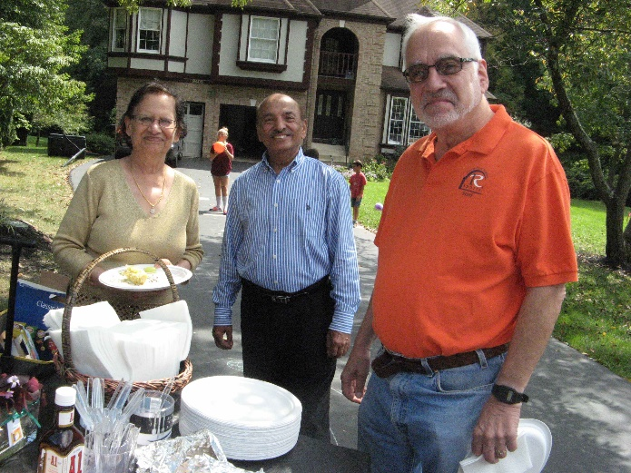
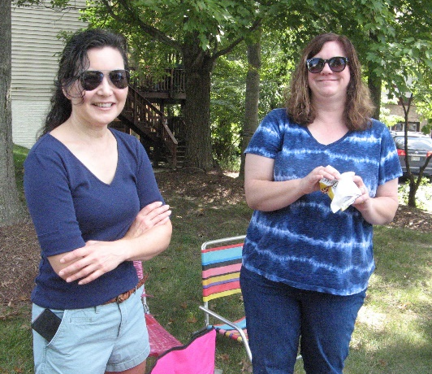
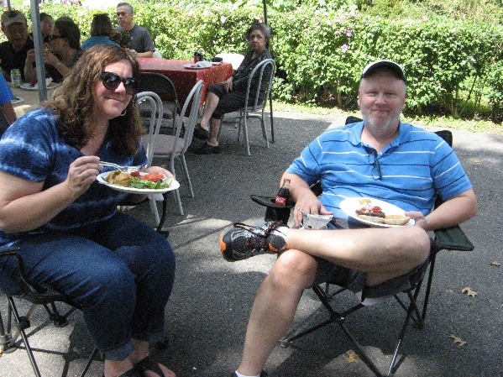
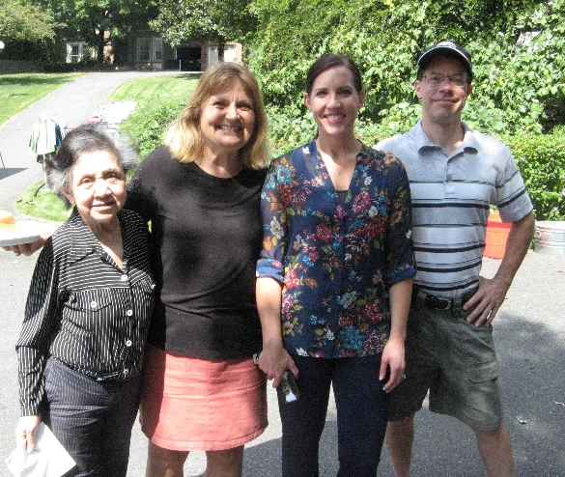
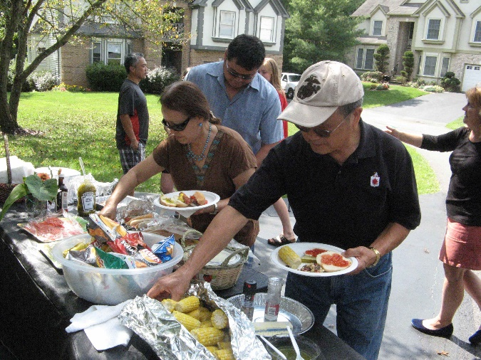
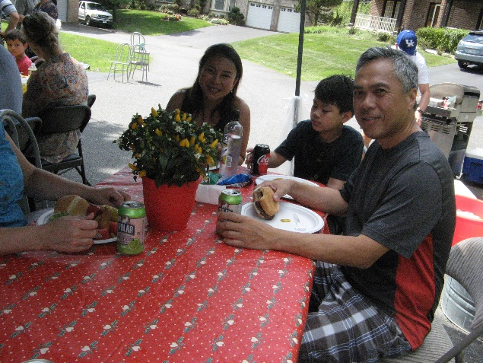
WINTER HOME REMINDERS
A maintenance check carried out in the fall will have you better prepared for inclement weather this fall and winter. Here are some friendly reminders:
- replace any burnt out bulbs on the exterior lights
- trim tree branches and bushes off windows, siding, and lampposts
- trim branches and move border rocks at least 6-inches off sides of sidewalks
- inspect and clear rain gutters of leaves
- check for any loose or missing roof shingles or siding
- check/replace filters for heat pumps and furnaces
- check and clean air ducts and registers
- have fireplace chimneys inspected and cleaned
- check wooden decks/porches for loose nails and rotted wood
- help keep sidewalks safe by shoveling snow as soon as feasible

2015-2016 BOARD ACCOMPLISHMENTS
- Continued upkeep and maintenance of the front entrance with light and plants
- All assessments collected (56 homes, 9 pipestem)
- Clean audit of financial records by independent certified public accountant
- Hosted annual yard sale and picnic

SUGGESTIONS
Have a suggestion for the HOA board? Things you like to recommend, something that’s been nagging you, something that we could change? Something you are pleased about? Please call a board member or email and let us know.

WOODED GLEN HOMEOWNERS ASSOCIATION CONTACTS
Board of Directors: (area code 703)
President: Tom Clark, phone 244-5442
Vice President: Richard Golden, 569-1264
Treasurer: Al Graziano, 455-3447
Secretary: Michael McCrory, 455-0806
At Large: Linda Hamm, 455-7118
Architectural Control Committee
Walt Zimmers, 646-2087
Gail Levenson, 451-8351
Beth Samec, 455-0977
Volunteers Wanted (contact Mr. Zimmers):
Phone: 646-2087
Email: Walter.Zimmers@gmail.com
Grounds Committee
Richard Golden, 569-1264
Walt Zimmers, 646-2087
Debbie McCrory, 455-0806
Helmut Draxler, 913-1114
Beverly Hirschfeld, 978-8244
Patrick McLean 455-3158
Linda Bruhn-Cherry
Volunteers Wanted

Proxy for Meeting of the Wooded Glen Homeowners’ Association

The annual meeting of the Wooded Glen, Section I Homeowners’ Association, Inc (WGHOA) has been scheduled for November 6, 2017, at 7:30 p.m. at the Pohick Regional Library: .

If you are unable to attend, please sign and give this proxy to any one of the
following board members:

PROXY: I hereby appoint the following persons, or any of them, as my proxy for this Annual HOA Meeting

President: Thomas Clark, phone 244-5442
Vice President: Richard Golden, phone 569-1264
Secretary: Michael McCrory, phone 455-0806
Treasurer: Al Graziano, phone 455-3447
Member at Large: Linda Hamm, phone 455-7118

and I give him/her/them the following instructions:

To vote me “present” for quorum and to vote on matters of business being conducted, including the following:

1. A vote will be taken to fill three open seats on the Association’s board of directors.

2. A vote will be taken to increase the annual assessment from the current $450 to an amount not greater than $600.

Date: _________________

Signature: _______________________________________________________________

Print Name: _____________________________________________________________

Address: ________________________________________________________________

Telephone Number: ______________________________________________________

