Wooded Glen, Section I Homeowners' Association, Inc.
October 2016
http://woodedglenhoa.org/
NEWSLETTER

ANNUAL HOA Meeting 22 NOVEMBER 2016
The annual meeting of the Wooded Glen, Section I Homeowners’ Association Inc., has been scheduled for Tuesday, November 22, 2016, at 8:00p.m. in the Sangster Elementary School, located at 7420 Reservation Drive, Springfield 22153. At least one homeowner from each home should attend to represent their home in the Association.

Elections will be held to fill three Board member positions for two-year terms (Nov 2016 – Nov 2018). If you are interested in running for one of these positions, please mention it to a current Board member or neighbor who plans to attend. We are also looking for members of the Architectural Control Committee (ACC) and Grounds Committee.

In addition to the elections, the current board will present the association’s budget for the next fiscal year. The costs of running our Association are currently stable thanks in large part to our Treasurer’s continued efforts.

The meeting is open to all members of Homeowners’ Association and renters. Only homeowners can vote. Homeowners who cannot make the meeting are asked to complete a proxy (located at the back of this newsletter).

On the whole, our neighborhood is in fine shape, thanks to everyone who makes the effort to maintain their properties. It often takes only a few minor tasks to help improve the looks of our neighborhood. Our goal is to make Wooded Glen a highly sought-after neighborhood that others looking to buy will want to move into.

A reminder to homeowners making exterior or grounds changes: please consult with the Architectural Control Committee first. A simple email or call is all it takes. They can and will assist and advise you. They can guide you through the ACC request process, if one is necessary. This includes painting and tree removal.

I encourage anyone interested in our HOA, and our neighborhood, to volunteer for a seat on the Board of Directors. It takes only a couple of hours a month of your time.

NEIGHBORHOOD SAFETY
Ours is a very safe neighborhood. Although in the past we have had some minor acts of vandalism and petty larceny, things have been quiet this year. Nevertheless, it is always wise to take common-sense precautions. Autos parked on the street have been targets of petty criminals in the past. To deter those who might be tempted, all homeowners should lock their cars and secure valuables out of site. And keeping your exterior lighting well maintained will also serve as a deterrent.

We’re all neighbors and should look out for one another. If you see anything suspicious, please contact 911 or the Fairfax County Police Department Non-Emergency Line at 703-691-2131. The best deterrent is a vigilant neighborhood.

REPLACEMENT BULBS, GLOBES and LAMP POSTS
Homeowners, please take a look at your lamp post. Some are showing their wear. The Board requests that the bulbs be uniform. All bulbs on the entire street should have the same wattage and color rendition. If you need bulbs, please contact the Grounds Committee or any of the Board members for replacement. The Grounds Committee has been helping homeowners replace bulbs. The Committee has also assisted in replacing rusted steel screws with stainless steel screws. Feel free to contact any member of the Grounds Committee for assistance.

You can also contact any member of the Grounds Committee for assistance in replacing the 12-inch plastic globes for your lamppost fixture.

PLEASE PICK UP AFTER YOUR PETS
Fairfax County Code Title 41 requires pet owners to have their pet on a leash when left outside and to pick up their pet’s waste. From time to time homeowners in Wooded Glen have noticed unleashed pets running around at night and pet droppings on their lawns, in the common areas, and in the parkland near the townhomes. Our children play in these areas. Remember to bring a bag and flashlight at night. Darkness does not hide the waste. Please DO NOT dispose into the sewer drains.

Anyone seeing a homeowner not picking up waste after his or her pet should politely ask the pet owner to do so. If the polite reminder does not work, violators may be reported to the Fairfax County Animal Warden at (703) 691-2131. However, aggressive actions against pet walkers are not recommended.
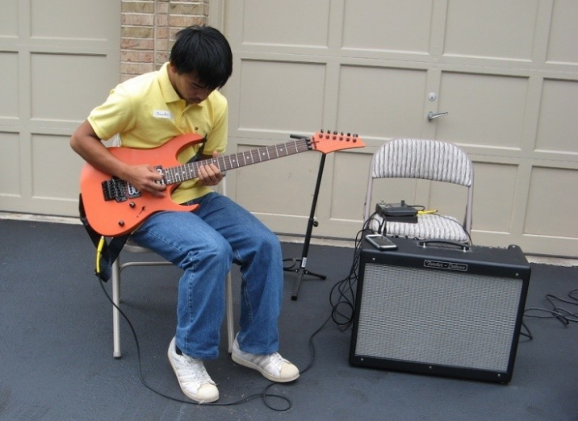
HOW TO CHANGE THE EXTERIOR OF YOUR HOUSE
Does the color of your house need a change? Do you wish you had a back deck or fence around your yard or do you want to change the one you have? Do you have a tree that needs to be removed? If so, then you have to request approval for an exterior change of your house from the Architectural Control Committee (ACC). The Wooded Glen guidelines state: “Applications shall be submitted to the Committee in an original plus five copies.” You can also send your application electronically to acc@woodedglenhoa.org. or Walter.Zimmers@gmail.com. Applications shall contain detailed drawings of changes to be made. Such drawings shall clearly indicate the location of existing structures, and property boundary lines.”

The approval process is simple; use the form located on our website or write a letter explaining exactly what you want to do, add a drawing, and if painting is involved, submit a sample of the color(s). Sometimes the ACC receives requests when nothing is really required. Before filling out the ACC forms, feel free to contact Mr. Zimmers at 703-646-2087, or email him at Walter.Zimmes@gmail.com. He will be happy to assist you as to whether or not ACC approval is required. If you send a request in hardcopy, you can provide Mr. Zimmers one copy with sample. He will then scan and circulate your request to the other members of the ACC once it is reviewed for compliance. A complete application normally takes no more than two days to be approved. Written approval of changes, additions or improvements to your home is a requirement of our Homeowners’ Association. To review the requirements in detail, see the link to the Architectural Guidelines on our web site at http://woodedglenhoa.org/.

HOA PICNIC FUN!

Our annual picnic was held on Sunday, September 25. It was another great event organized by Debbie McCrory. The Board extends a huge thank you to Debbie for pulling it all together, again.

Also, a special thank you to Brandon Em for the musical entertainment and the Goldens for taking care of the grilling. Thank you to the Hirschfeld, Mustone, Sikri, Em, and Draxler families for all their help to make the picnic a success.
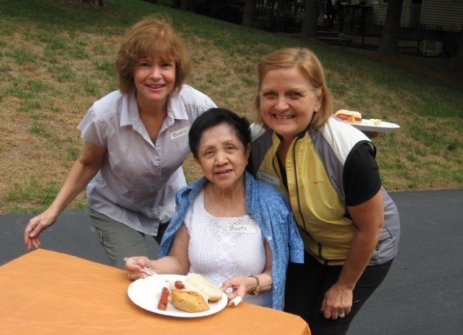
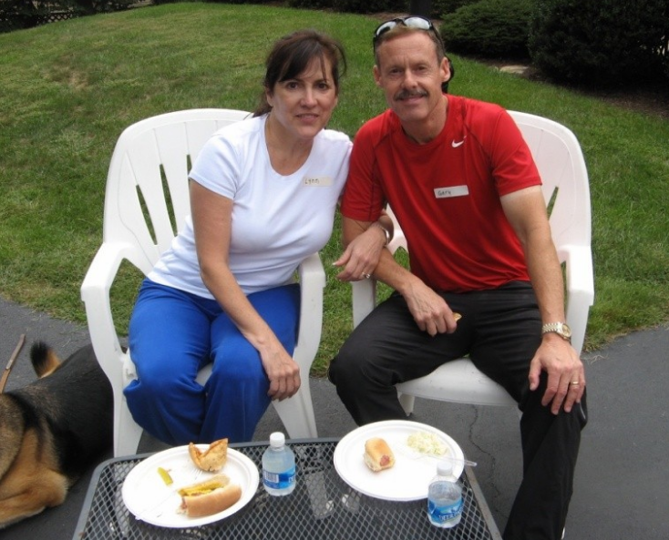
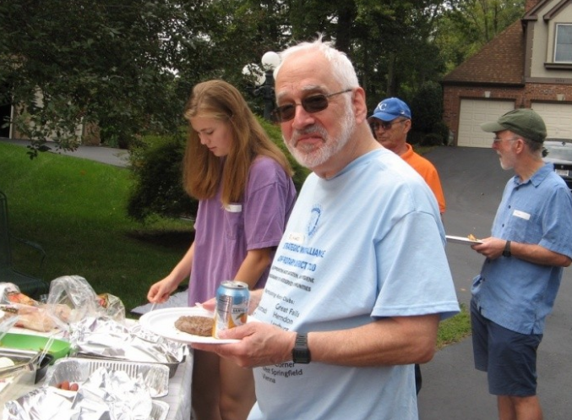

WINTER HOME REMINDERS
A maintenance check carried out in the fall will have you better prepared for inclement weather this fall and winter. Here are some friendly reminders:
- replace any burnt out bulbs on the exterior lights
- trim tree branches and bushes off windows, siding, and lampposts
- trim branches and move border rocks at least 6-inches off sides of sidewalks
- inspect and clear rain gutters of leaves
- check for any loose or missing roof shingles or siding
- check/replace filters for heat pumps and furnaces
- check and clean air ducts and registers
- have fireplace chimneys inspected and cleaned
- check wooden decks/porches for loose nails and rotted wood
- help keep sidewalks safe by shoveling snow as soon as feasible

2015-2016 BOARD ACCOMPLISHMENTS
- Continued upkeep and maintenance of the front entrance with light and plants
- All assessments collected (56 homes, 9 pipe stem)
- Clean audit of financial records by independent certified public accountant
- Hosted annual yard sale and picnic

SUGGESTIONS
Have a suggestion for the HOA board? Things you like to recommend, something that’s been nagging you, something that we could change? Something you are pleased about? Please call a board member or email and let us know.

WOODED GLEN HOMEOWNERS ASSOCIATION CONTACTS
Board of Directors: (area code 703)
President: Tom Clark, phone 455-5646
Vice President: Roger Kang,
Treasurer: Al Graziano, 455-3447
Secretary: Michael McCrory, 349-2010
At Large: Helmut Draxler, 913-1114
Architectural Control Committee
Walt Zimmers, 646-2087
Gail Levenson, 451-8351
Beth Samec, 455-0977
Volunteers Wanted (contact Mr. Zimmers):
Phone: 646-2087
Email: Walter.Zimmers@gmail.com
Grounds Committee
Richard Golden, 569-1264
Walt Zimmers, 646-2087
Debbie McCrory, 349-2010
Helmut Draxler, 913-1114
Beverly Hirschfeld, 978-8244
Patrick McLean 455-3158
Volunteers Wanted
e-mail: grounds@woodedglenhoa.org
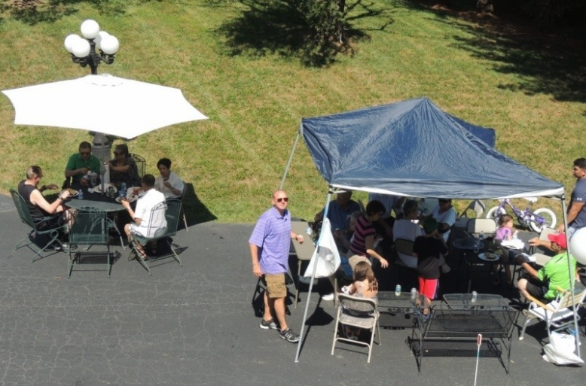

Proxy for Meeting of the Wooded Glen Homeowners’ Association

The annual meeting of the Wooded Glen, Section I Homeowners’ Association, Inc. (WGHOA) has been scheduled for November 22nd, 2016, at 8:00 p.m. at the Sangster Elementary School, 7420 Reservation Drive, Springfield, Virginia 22153. Three Board members for two-year terms are to be elected, and other business may be transacted at the meeting.

If you are unable to attend, please sign and give this proxy to any one of the
following board members:

PROXY: I hereby appoint the following persons, or any of them, as my proxy for this Annual HOA Meeting

President: Thomas Clark, phone 455-5646
Vice President: Roger Kang, phone
Secretary: Michael McCrory, phone 349-2010
Treasurer: Al Graziano, phone 455-3447
Member at Large: Helmut Draxler, phone 913-1114

and I give him/her/them the following instructions:

To vote me “present” for quorum and to vote on matters of business being conducted, including the following:

1. Our current by-laws require the presence in person or by proxy of Members holding 35% of the outstanding votes of the Association to constitute a quorum for all annual meetings. Virginia law has been amended to require the presence of only 10% of outstanding votes to constitute a quorum. A vote will be taken at this year’s meeting to amend our by-laws to require the presence, in person or by proxy, of 20% of the outstanding votes of our Association to constitute a quorum.

2. A vote will be taken to fill three open seats on the Association’s board of directors.

Date: _________________

Signature: _______________________________________________________________

Print Name: _____________________________________________________________

Address: ________________________________________________________________

Telephone Number: ______________________________________________________

